L06: Preparation Assignment Worked Solutions
Name: ____________________
Part I: Use the information in the reading assignment to complete these questions.

1. What is the sampling distribution?

The sampling distribution is the set of all possible sample means from a population. Although we will only see one sample mean in our study, there are many sample means that could have possibly been observed.

2. What is the shape of the sampling distribution of the sample mean when the data are normally distributed?

Normal

3. What is the shape of the sampling distribution of the sample mean when the data are not normally distributed, but the sample size is large?

Approximately Normal according to the Central Limit Theorem.

4. How does the shape of the sampling distribution of the sample mean change when the sample size is increased?

The sampling distribution more closely approaches a normal distribution and the standard deviation decreases. The mean is unchanged.

- What is the difference between the Central Limit Theorem and the Law of Large Numbers?

The Central Limit Theorem states that if the sample size is large, the sample mean will be approximately normally distributed. That is it. The Law of Large Numbers states that as the sample size increases, the standard deviation of the sample mean will get smaller.

- When is x-bar normally distributed?
X-bar is normally distributed if the data were drawn from a normal population, or if the sample size is sufficiently large.

Please cut out the squares on the following page. Select five at random and compute the sample mean (x bar). An alternative to cutting them out is to go to http://www.random.org/integers and generate 5 random integers between 1 and 30. Use the salaries from the 5 squares corresponding to your 5 random integers to compute the sample mean (x-bar). You will use this information to complete Part II.
Directions:
These numbers represent the starting salaries (in US $) of recent graduates in Finance.
$45,000  #1 | $39,500  #2 | $47,100  #3 | $47,800  #4 | $3,4400  #5
$45,000  #6 | $47,900  #7 | $47,300  #8 | $42,800  #9 | $45,500  #10
$45,300  #11 | $57,800  #12 | $52,800  #13 | $48,500  #14 | $40,200  #15
$44,300  #16 | $39,600  #17 | $50,000  #18 | $43,600  #19 | $37,900  #20
$52,900  #21 | $59,500  #22 | $48,300  #23 | $52,100  #24 | $45,000  #25
$49,800  #26 | $46,900  #27 | $44,400  #28 | $45,000  #29 | $45,200  #30

Part II: (Answers Will Vary for this section.)

7. Randomly select 5 of the 30 salaries and compute the mean.
a. What is the mean of your sample?
This depends on which of the 5 salaries you drew. There are 142,506 possible answers here so here is just one example answer.

Example Answer: I drew 44,400, 45,000, 48,300, 57,800, and 47,800. The mean of my sample is 48,660.

b. This graph illustrates the sampling distribution of the sample mean. There are 142,506 possible combinations of the 30 salaries, drawn 5 at a time. This graph represents the distribution of all possible samples. Make a mark on the horizontal axis to indicate the value of your sample mean from part a.
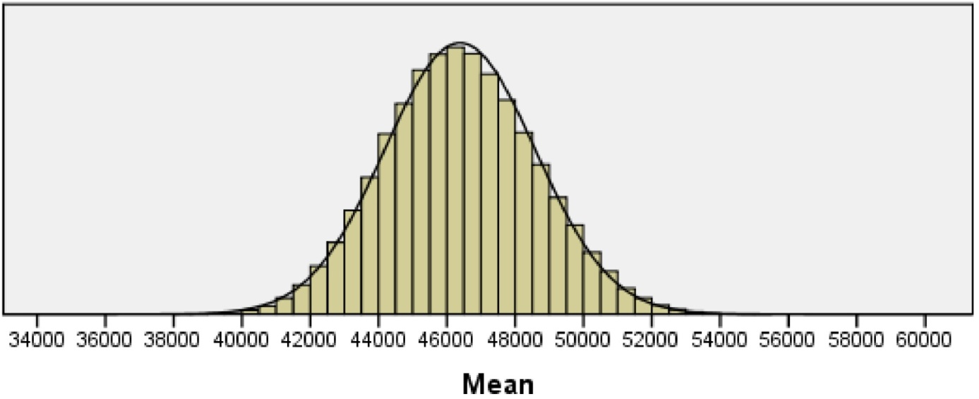

c. Does your sample mean appear to be unusual? Explain why you think it is (or is not) unusual.

Again this will depend on what your sample mean was. My example sample mean does not appear to be unusual. It is fairly close to the center of the curve.
d. Compare your mean from question 8a to the means obtained by at least three other individuals. What do you notice? In practice, you only get to see the means from the samples you draw. You do not get to observe any other mean that could have occurred.

- The Graduate Management Admission Test (GMAT) is used as an admission criterion in many masters of business administration (MBA) programs. The scores on the GMAT are normally distributed with a mean of µ=529 and a standard deviation of σ=113.
Consider a simple random sample (SRS) of n=10 students taking the GMAT.

  - What is the shape of the distribution of the sample means for all such samples?

Normally Distributed

  - How do you know that the distribution of the sample mean has this shape?

The parent population is normally distributed

  - What is the mean of the sampling distribution of sample mean scores for all such samples?

Mean of the sampling distribution of the sample mean is equal to that of the parent population µ=529.

  - What is the standard deviation of the sampling distribution of the sample mean scores for all such samples?

Standard Deviation = $σ/\sqrt{n}$ = 113/$\sqrt{10}=35.734$

